
English Policy
At Pleasant Street Primary School, we believe that literacy and communication are key life skills. Through the English curriculum, we will help children develop the skills and knowledge that will enable them to communicate effectively and creatively through spoken and written language and equip them with the skills to become lifelong learners. We want children to enjoy and appreciate literature and its rich variety. Through a range of high-quality texts and experiences we endeavour to ensure that our children enjoy participating in lessons, developing a positive and enthusiastic attitude towards English lessons that will stay with them for life.

Aims
- Confident communicator with excellent speaking and listening and oracy skills
- Has a range of vocabulary that they can use in conversations and their writing across subjects
- Show an enjoyment for reading, reads often for both pleasure and information
- Read fluently with a good understanding of what they have read
- Articulate feelings and formulate responses to a range of texts using appropriate vocabulary
- Write clearly, showing stamina in a range of genres for a range of audiences and purposes, adjusting their language and style accordingly
- Be able to express opinions confidently
- Use grammar and punctuation accurately
- Understand spelling conventions
- Produce effective, well-presented written work.

Expectations
We aim to ensure that every child achieves success and that all are enabled to develop their skills across the English curriculum in accordance with their individual level of ability. When teaching our English curriculum, we want our pupils to acquire the knowledge and understanding and skills to become lifelong learners with excellent communication skills. The curriculum is designed to ensure that pupils develop their reading, writing, phonics and oracy skills in both English lessons and across the wider curriculum.

Curriculum, teaching and learning
Children will be taught in their normal class group for English, basic skills and phonics sessions and all classrooms should have a washing line dedicated to their current text for both adults and children to refer to. All pupils take part in a daily English lesson based on the Literacy Counts scheme of work, ‘Read to Write’ (see Appendix 1). The teaching of writing is through carefully constructed units based around high quality texts. Each unit of work starts with a hook lesson to create interest, the unit then leads to an analysis of the text, before the pupils plan and write their own work. Books linked to the genre and other high-quality texts are displayed in the class library for the children to explore and enjoy.
Phonics is taught systematically throughout the school in EYFS and KS1 daily and continues for some pupils in KS2 using the Monster Phonics scheme of work. Language development, phonics and reading is also supported through high quality interventions for pupils requiring further support.
Reading is an integral part of our school curriculum, pupils read regularly with school staff, and a love of reading is promoted across the school. High quality texts are used to support the wider curriculum, and pupils have access to class libraries and a well-stocked school library. Reading sessions in class vary depending on phonics understanding and key stage (see appendix 2).

Additional basic skills sessions take place outside of the daily English lesson. The sessions include explicit teaching of spelling and grammar, comprehension sessions and whole class reading. The sessions are planned against age related expectations and include opportunities to link with previous, current or future learning.

Assessment
English is assessed using a combination of Formative Assessments and teacher judgement (see appendix 3).

Staff development
Teachers are expected to keep up to date with subject knowledge and use current materials that are available in school or online. Regular CPD is provided for all staff both internally and external providers.

Monitoring and evaluation
English is monitored through book looks, walk arounds, pupil interviews and teacher evaluations.
Pupil progress is monitored through on-going teacher assessments and termly formal assessments.

Phonics
Pupils are assessed following the assessment schedule in the Monster Phonics planning, this information is used to set targets, and it informs catch-up group sessions. This information is also shared with parents and carers so they can support learning at home. Please see the phonics page on our website for more information.

Spellings
Teachers use the teaching format of Superhero Spellings. Children take part in a ‘Show Me’ session of Fridays to assess their understanding and application of spelling rules (see Appendix 6).

Baseline

Teachers will have access to children’s previous years assessment levels to help understand each child’s starting point for that year. Both the writing and phonics progression documents will be used to see what objectives the children need to access to ensure effective teaching and learning takes place.

Appendix 1
English Teaching / Books
English is taught daily across EYFS, KS1 and KS2, following the school’s chosen planning scheme Literacy counts. English planning can be accessed online using a school login. Each unit is made up of ‘Immerse’, ‘Analyse’, ‘Plan’ and ‘Write.’ The lesson plans include sentence accuracy which can either be recorded in books or on whiteboards. There should be evidence of incidental writes, plans and ‘final pieces. Any lessons that do not have a written writing outcome should be recorded in a class floor book (see appendix 5).

Learning Walks
Throughout the unit, writing should be modelled of flipchart paper and then displayed on class washing lines for children to refer to. Teachers should create resources that enable all pupils to achieve success within the lesson.
For children very new to English, activities should be adapted to allow them to work on relevant Nassea targets.

Appendix 2

Reading
In EYFS and KS1, the monster phonics paired reading model is followed 3 x a week (see appendix 4). Children with phonics targets will also read 1:1 with an adult. In KS2 children read 1:1 with a support staff weekly and 1:1 with the class teacher termly. Children are assessed on 2eskimo to determine current reading level at staff discretion. When needed, targeted children will have additional weekly reading sessions. Additionally, children take part in 2 Whole Class Reading sessions a week as well as weekly comprehension activities. These are both used to inform teacher judgement.

Appendix 3

English Assessment
Teachers use TAF (Teacher Assessment Framework) statements provided by Literacy counts. These will indicate whether a child is working towards, at or above the expected standard for their year group. For those working well below, the TAF statements for previous year groups will allow teachers to make accurate judgements. These annotations will be used for termly internal moderation.
Children are assessed using NFER for reading and SPaG termly. These tests will be undertaken to enable teachers to assess and record pupil progress, as well as to use the outcomes to inform future planning.

All Age-Related Expectations data/test results to be recorded using the NFER Online Hub. Analysis of assessment data is used to set targets and alter teaching to address identified target groups, the data also provides comparisons with other pupils nationally.

Appendix 4

Paired Reading Model
The book that links to the current week’s teaching is read in 3 sessions across the week in mixed-ability pairs.
Session 1
- Adult to Introduce the book for the week ask Children for their predictions.
- Read through the HFW/ Tricky words inside front cover then pick a word at random and ask. Children to find and point to the word and then all together sound it out and blend using pointing finger.
- Adult to read the book with children following along.
Session 2
- Children take turns to read the first few pages of the story. Partner 1 points to the words, whilst partner 2 reads – the partners then swap at the bottom of each page.
- Adult circulates and listens to different partners as they are reading.
- Adult then reads a page of story to the children to model reading with fluency and expression. The Children follow and ‘jump in‘ with the word when the adult hesitates.
Session 3
- Children take turns to read the rest of the story. Partner 1 points to the words, whilst partner 2 reads – the partners then swap at the bottom of each page.
- Adult to circulate and listen to different partners as they are reading.
- Adult to ask the children the questions at the back of the book and discuss.

Appendix 5

When there is no writing outcome in an English lesson, an oracy focus is in place for children to practice the different strands of oracy. There could be 2/3 focuses per session.
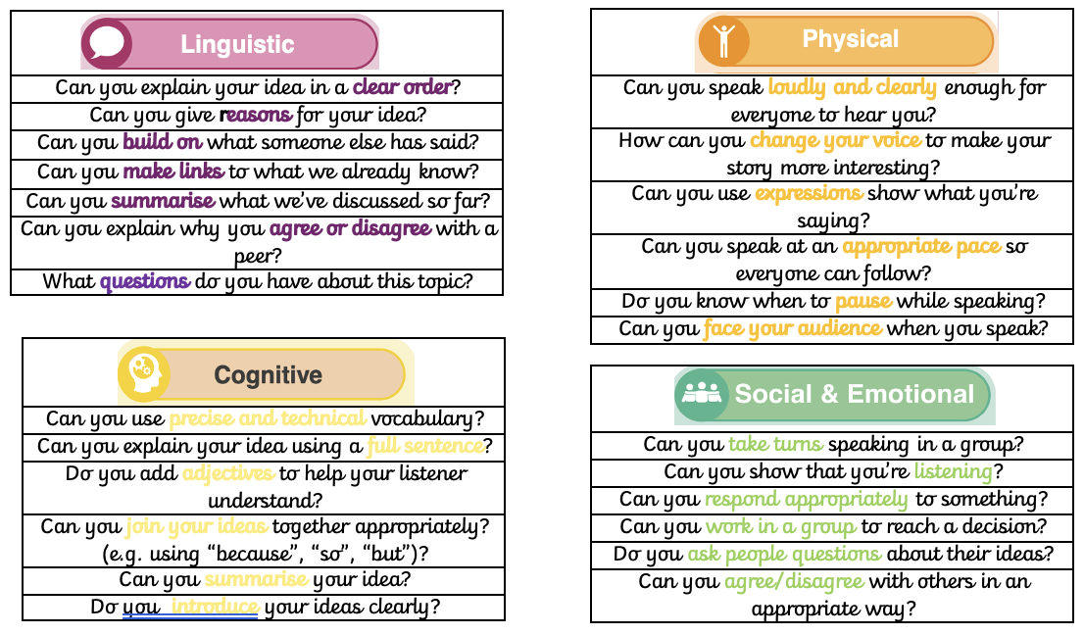

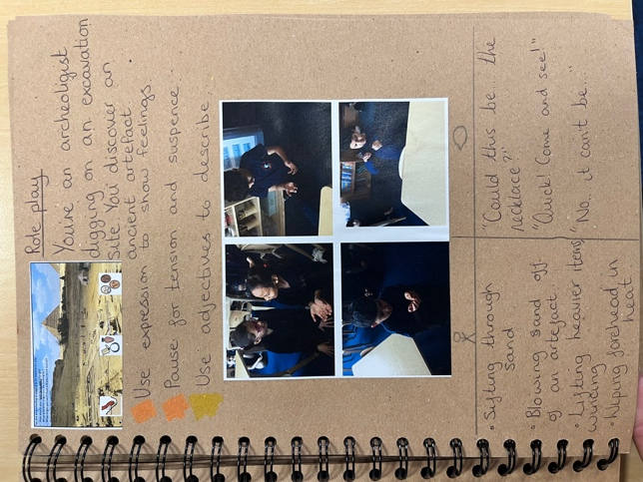
Photographs and applicable annotations should evidence these sessions in the class floor book, with the focus clear.
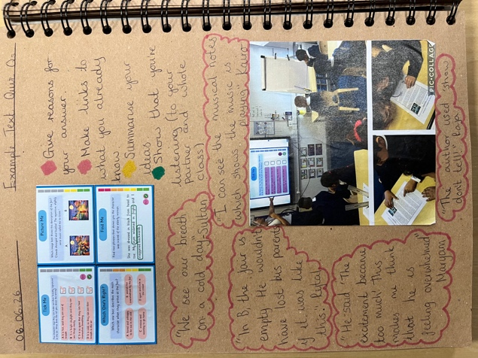
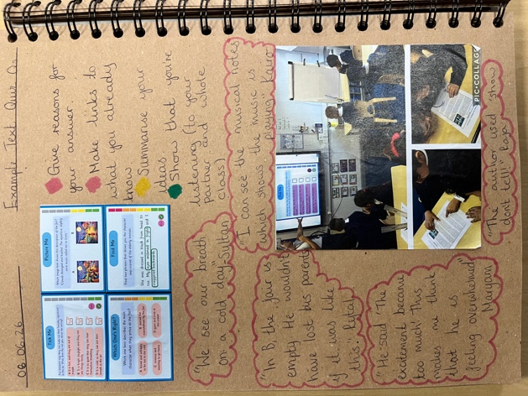

Appendix 6

8:30 time should include a selection of activities from this week’s spelling list. Include a wordsearch and handwriting sheet and any others that you feel are appropriate. Spelling lists are to be given out/posted on Seesaw every Monday.

Years 3 – 6 have a session timetabled after lunch Mon-Thurs to work through the ‘Learn’ and ‘Build’ teaching points. During Monday’s session, spellings should be added to the English washing line with the spelling rule made clear for children. It should stay up for the whole week and be referred to when appropriate.

On Fridays there should be a dedicated slot for the ‘show me’ session that does not feel rushed. Again, this might be after lunch but could be worked around swimming if that works best.

Records are kept of children’s scores. There will be sticker prizes both for children who scored 10/10 and for those who improved on last week’s score.

Appendix 7

Monitoring
The monitoring of English with include learning walks to ensure the classroom environment follows policy and can be used as an additional resource for children in lessons, the analysis of data and key groups termly, Staff and Pupil Voice and Book Looks to ensure that work is presented to a high standards and teaching expectations have been followed.

